**CN Quiz 6**

Name: Erwin Wu

Student ID: 17M38147

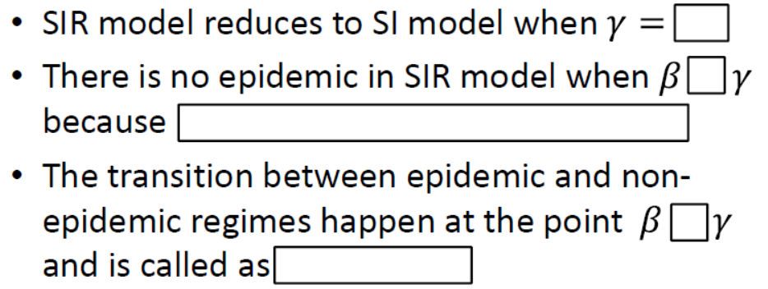

epidemic transition

=

recovery (I->R) is faster than infection (S->I)

0

≤